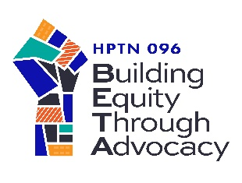
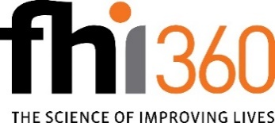

Attachment A: Applicant Response Form
Solicitation Title: | Health Equity Community Coalition Lead Organization – DALLAS, TX
Solicitation Number: | FY22-HPTN-096-05042022-01
Name of Organization: | Click or tap here to enter text.
Applying under fiscal sponsor? | ☐Yes ☐ No
If yes, name of fiscal sponsor? | Click or tap here to enter text.
UEI Number: | Click or tap here to enter text.
Name and title of proposed Project Director: | Click or tap here to enter text.
Project Director E-mail address: | Click or tap here to enter text.
Project Director phone number: | Click or tap here to enter text.
Project Director mailing address: | Click or tap here to enter text.
Name and title of Contracts/Grants Administrator (if applicable): | Click or tap here to enter text.
Contracts/Grants Administrator E-mail address: | Click or tap here to enter text.
Contracts/Grants Administrator phone number: | Click or tap here to enter text.
Contracts/Grants Administrator mailing address: | Click or tap here to enter text.
Advance Requested:  (A grantee may receive an initial advance equal to the total value of the grant divided by the number of months in the period of performance or other such among as may be justified by detailed estimate of expenses for first 30 days of performance. The grantee may submit a request for subsequent advances. Grantee must submit reconciliation for each advance no later than 15 days after period for which advance was provided.) | Yes ☐  No ☐

Evaluation Criteria:
- Why is your organization/coalition interested in this opportunity?
Click or tap here to enter text.
- What is your organizational/coalition mission statement?
Click or tap here to enter text.
- Please provide a brief (no more than half page) description of previous experience with community organizing, advocacy and/or civil engagement.
Click or tap here to enter text.
- Please describe how your organization/coalition has demonstrated ability to work and communicate thoughtfully across diverse populations.
Click or tap here to enter text.
- What is your vision for what community mobilization and coalition building would look like in your community, specifically to achieve health equity in HIV prevention and treatment for Black gay, bisexual, and same gender loving men in Dallas?
Click or tap here to enter text.
- Please describe the potential (or existing) members that could become part of the COALITION or may be already relevant to the objective of a coalition, as well as envisioned structure and governance of the COALITION. For existing coalitions, include a description of how long the coalition has been in existence, geographic focus, and examples of activities/accomplishments.
Click or tap here to enter text.
- Please provide a brief statement attesting to your willingness to work in a culturally responsive manner with Black gay, bisexual, and same gender loving men.
Click or tap here to enter text.
- Please provide a brief (no more than half page) description to describe how you are connected within your community, including what kinds of partnerships you may have with other organizations or stakeholders.
Click or tap here to enter text.
- Once the coalition is established, how would your organization as LEAD ORGANIZATION facilitate and support the COALITION in accomplishment of the HPTN 096 COALITION activities?
Click or tap here to enter text.
- What steps would be taken to facilitate sustainability of efforts to improve equity in HIV prevention and treatment for Black MSM beyond the study?
Click or tap here to enter text.

